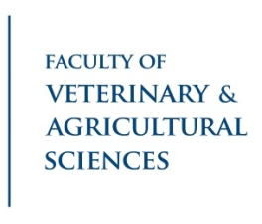
Qualitative Multivariate Analysis (QMA)

A QMA is: Qualitative: description of qualities or characteristics rather than quantities or measured values.
Multivariate: encompassing the simultaneous observations of more than one outcome variable.
Analysis: detailed examination of the elements or structure of a product.

In other words – QMA is a method for sorting groups (eg products, packages) with reference to each other
(eg similarities and differences) based on their qualities.

As a small or medium size company, you typically already have a model of how the market works in Australia. You know what works for your brand or products. As you consider exporting to Asia, this sorting of products or packages by ‘new-to-Australia’ consumers (from your anticipated market) will give you a ‘disaster-check’ and can provide powerful insights into your target consumers BEFORE you do expensive in-market research or export directly.

This disaster-check allows you to understand the differences in cultural biases between Australia and your considered Asian Market. Products are typically evaluated in a holistic way by consumers: the product is tasted, the package is evaluated and the brand is considered. This method is much closer to how consumers normally interact with products. (New-to-Australia consumers have typically been in Australia less than 2 years.)

Outputs:
- How your product, package, brand or technology is positioned in relation to in-market products identifying common / different attributes. This is valuable when you are negotiating with retailers in your export market.
- What key cues are more familiar or unfamiliar so you can understand what barriers you may encounter and plan to mitigate, and which attributes to leverage for future products.
- Identification of adjacent categories to provide attributes that might be more familiar to the consumer.
- Identification of consumer frameworks in the marketplace.
- Identification of potential white space or opportunities in the marketplace.
- Identification of hypothesis and needs to test for future research.
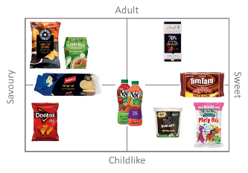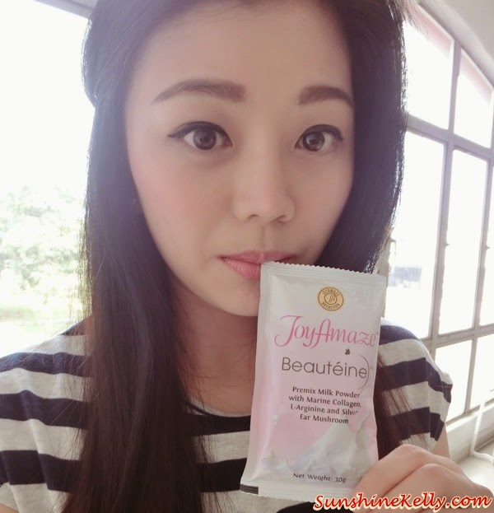

This innovative program is available through partnerships with the University of Melbourne and the Food Innovation Centre. Future sessions will also be made available in Queensland and South Australia.

What do I have to do to be part of this?

- Email us to schedule an appointment at food-value-chain@unimelb.edu.au
- Please note you will need to provide stimuli (samples) for consumers to touch and or taste. There will be a discussion on what other in-market stimuli is needed for assessment. Typically 15 to 20 stimuli are used in a session.

